AWS EC2 TASKS
1.Launch one EC2 using Amazon Linux 2 image and add a script in user data to install Apache.
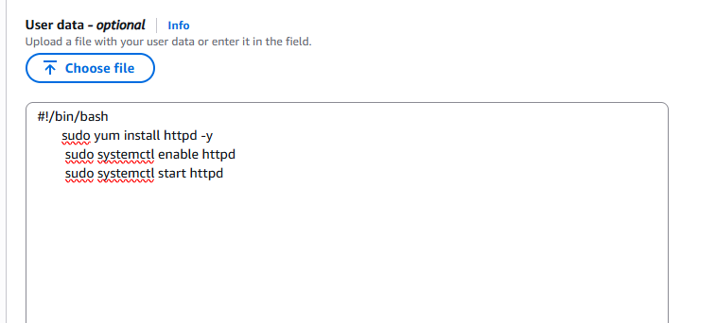
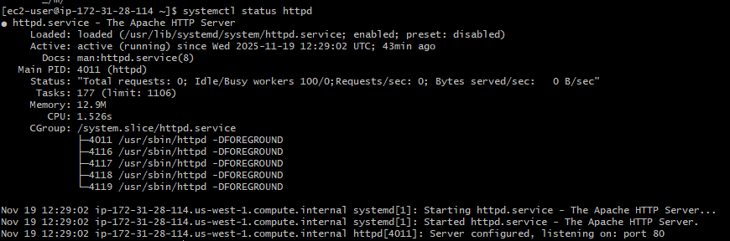

2.Launch one EC2 using Ubuntu image and add a script in user data to install Nginx.
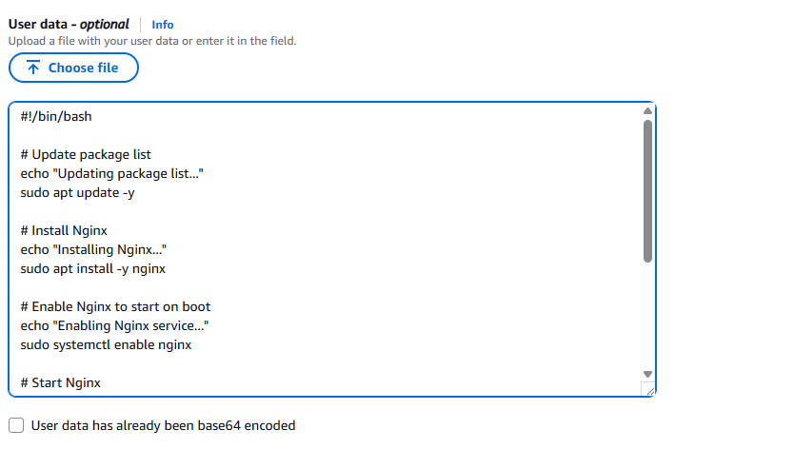
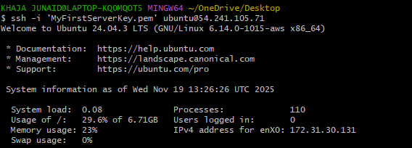
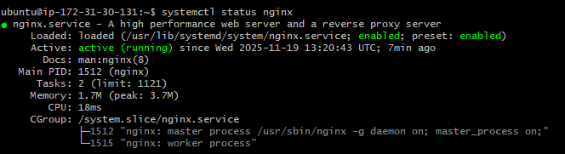

3.Launch one Windows server and install Tomcat on Windows.
Dycript .pem key for windows password:
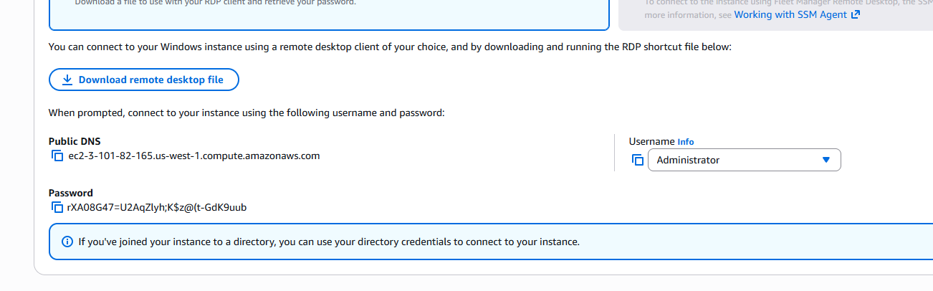
Windows server install java before installing tomcat
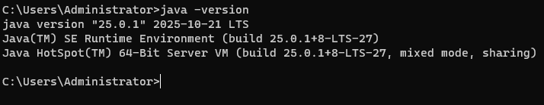

Tomcat services is running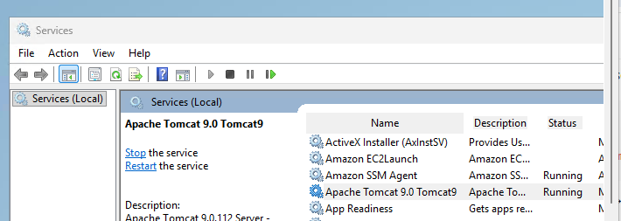
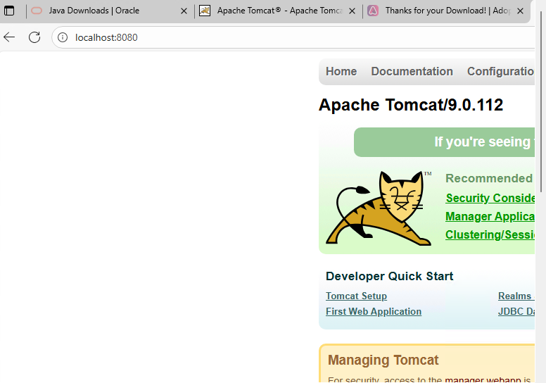

- Take a snapshot of the instance created in Task 1.
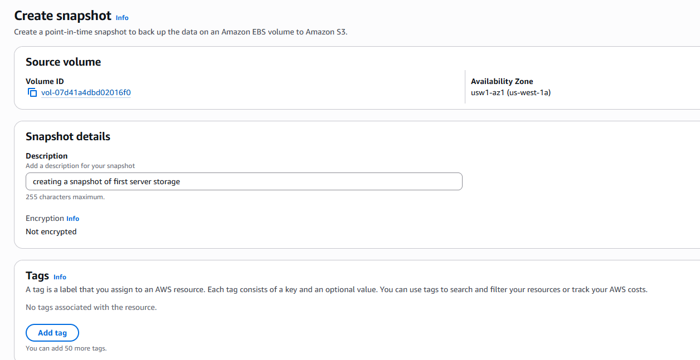
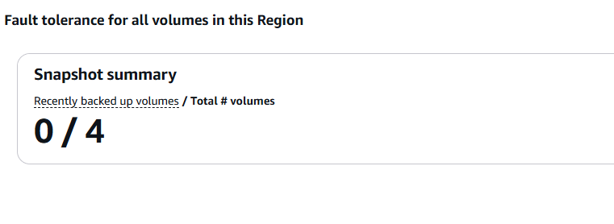
- Assign passwordless authentication for the EC2 created in Task 2.
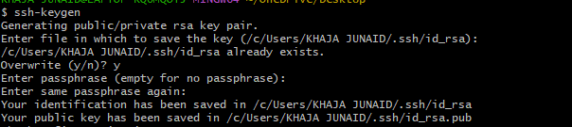
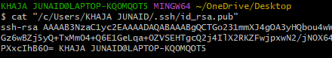
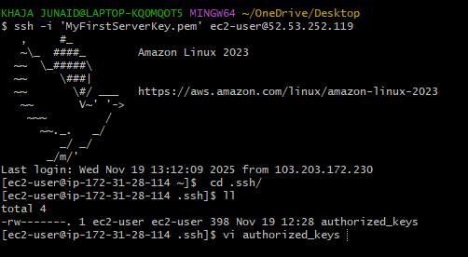

After adding ssh key authoriedskey file.Its create with .pem key login.
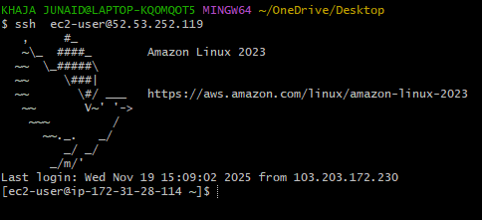
6.Launch any EC2 using the spot purchasing option.

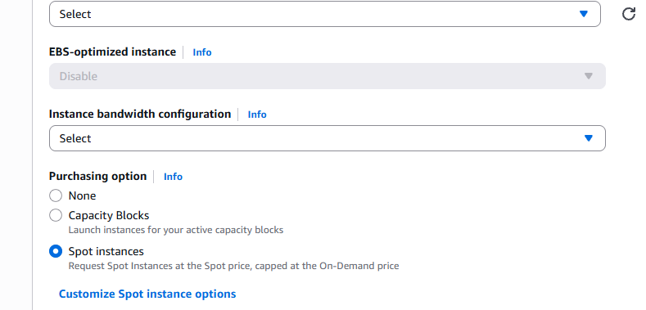

7. Enable termination policy on the EC2 created in Task 2.
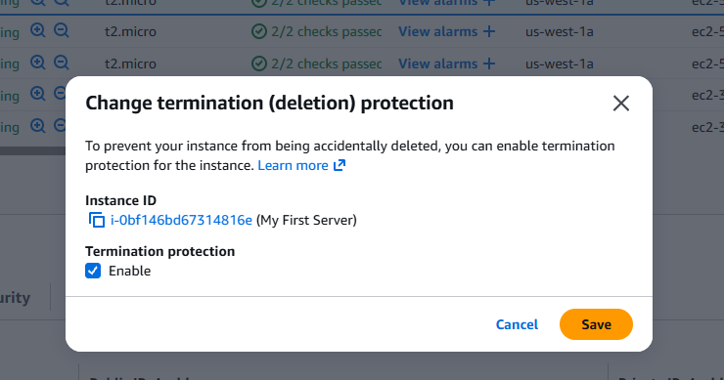

8. Launch one EC2 using AWS CLI.
